

**FACULTY OF ENGINEERING**

**ELECTRICAL – ELECTRONICS ENGINEERING DEPARTMENT**

1Hz-1 MHz OSCILLATOR DESIGN AND IMPLEMENTATION

Group 14

2022

E2E361 COMMUNICATION SYSTEMS I

Course Teacher

Dr. Öğr. Üyesi Cihat ŞEKER

1Hz-1 MHz Oscillator Design And Implementation

YAVUZ SELİM ASLAN   
 *electrical and electronics engineering department*   
*KARABUK UNIVERSITY*KARABUK, TÜRKİYE  
ysaslan68@gmail.com

HALİL İBRAHİM AYAN  
 *electrical and electronics engineering department*   
*KARABUK UNIVERSITY*KARABUK, TÜRKİYE  
halilayan06@gmail.com

AHMED BAYRAK   
 *electrical and electronics engineering department*   
*KARABUK UNIVERSITY*KARABUK, TÜRKİYE  
ahmedbayrak.71@hotmail.com

BERAT DİKBAŞ  
 *electrical and electronics engineeringdepartment*   
*KARABUK UNIVERSITY*KARABUK, TÜRKİYE  
berat_dk_1967@hotmail.com

MURAT ALKAN  
 *electrical and electronics engineering department*   
*KARABUK UNIVERSITY*KARABUK, TÜRKİYE  
muratalkan0123@gmail.com

# Introduction

In this project, our aim is to design a signal generator that, square wave, triangular wave for different reasons (In third part, we explained these reasons). In this report we will detail why we produce frequencies between 1 Hz to 1 MHz . First of all, we started to search for the most suitable IC before starting the design. We decided to use IC which is XR2206 IC that can output sine wave choose it, the design process and the expected results of the oscillator.

# AVAILABLE OPTIONS

According to our research, we had a few options in mind that could produce frequencies between 1 Hz to 1MHz square, sine and triangular waves. These were 555 timer and Op-amp applications but we could not use these applications. Because we discussed with our friends who had tried before and did not get any positive result so that we decided to not use 555 timer. For Op-amp application, we did not get the frequency range that we want. Even if we get the frequency range that we want, it was very noisy.

# REASONS FOR CHOOSING THIS DESIGN

As we mentioned in the introduction, the reason why we use this IC is that it is more suitable for the project compared to its counterparts. Here are a few reasons for this:

* More compact design and less overall number of a components and parts included which is very important for the integrity of the circuit.
* Much less noise susceptibility and significant stability compared to the counterparts in the range less than 1 MHz
* Wide Supply Range, 10V to 25V
* Wide Sweep Range, 2000:1, Typical
* Excellent Temperature Stability, 20ppm/°C, Typ.
* Low-Sine Wave Distortion, 0.5%, Typical
* Low-Sine Wave Distortion, 0.5%, Typical

# PRODUCTİON PROCESS

## Design

As a result of our search, we designed our circuit using the Altium Designer program and checked whether it is in working condition.

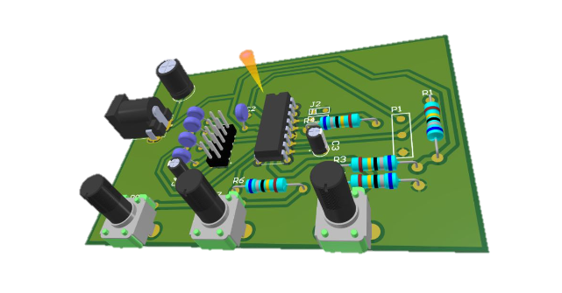

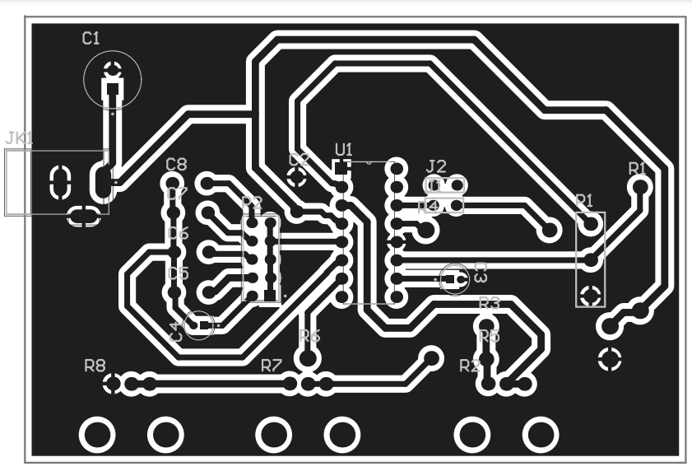

## Production

After supplying the materials, we checked whether the legs of the circuit elements match with the output of our Gerber file. Then we made a Gerber print on our plate. At first, we made this print with the help of an iron, but since we couldn't get the result we wanted from this method, we used another method, acetone print method. After we were successful in this process, we aimed to throw our plate in acid and create our roads and we got what we wanted. Then we drilled the holes in our plate with the help of a drill and placed the elements and we soldered the circuit elements we placed. Finally, a transmission control test was performed with a multimeter on the paths of the plate that we have completed.

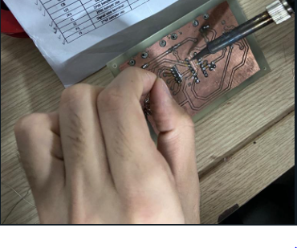 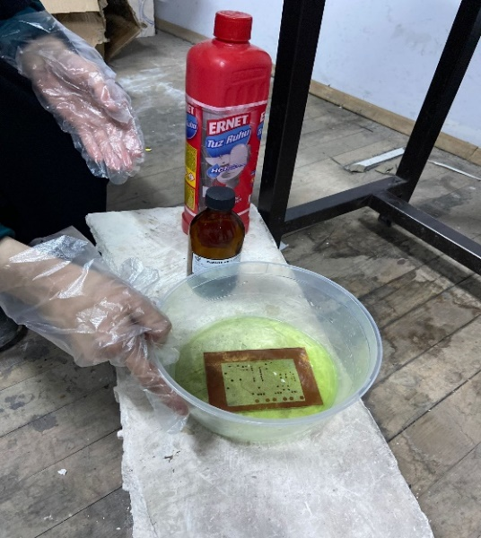

##### The final state of our circuit is given below

##### 

##### References

<https://www.alldatasheet.com/datasheet-pdf/pdf/80496/EXAR/XR2206.html>